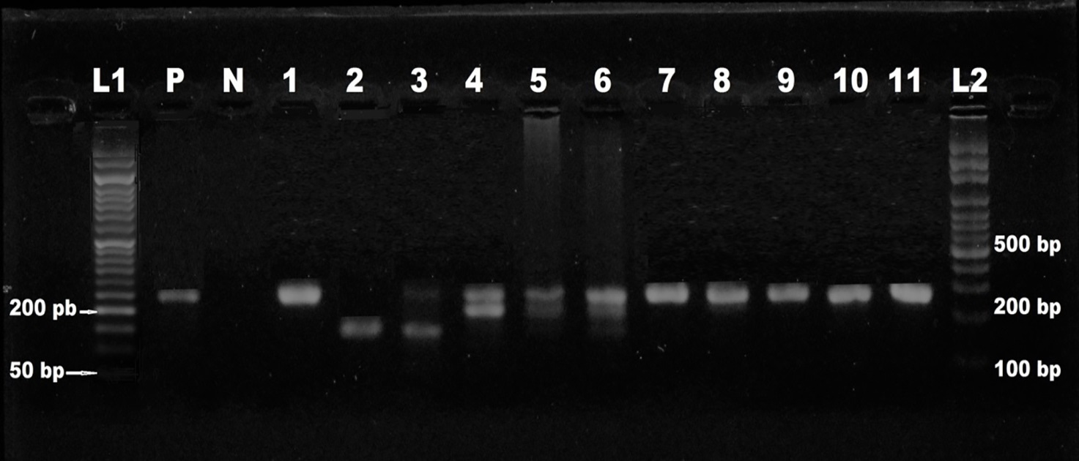
Additional file 2 Electrophoresis of the second-round (nested) PCR products. Agarose gel (1.5%) electrophoresis of the second-round (nested) PCR products. L1: 50 bp ladder, P: a positive control (Standard strain L. major), N: a negative control (distilled water), lanes 1-4 respectively: L. major, L. turanica, mixed infection of L. major and L. turanica and mixed infection of L. major and L. gerbilli (the infected smears of ear lobes of the rodents), lane 5: mixed infection of L. major and L. gerbilli, lane 6: mixed infection of L. major, L. turanica and L. gerbilli, lanes 7-11: L. major and L2: 100 bp ladder. Lanes 1-4 are from smears of ear lobes of the rodents and lanes 5-11 were isolated from X. nuttalli, E. oschanini, C. mesghalii, N. ziarus, D. sanguineus, Hirstionyssus sp, and R. sanguineus respectively.

